Contents

Screenshots 2

Code 2

Handler.cs 2

MileHandler.cs 3

FootHandler.cs 3

YardHandler.cs 4

Decorator.cs 5

RoundDecorator.cs 6

ExpDecorator.cs 6

ValutaDecorator.cs 7

Form1.cs 8

Form1.Designer.cs 9

Program.cs 11

# Screenshots

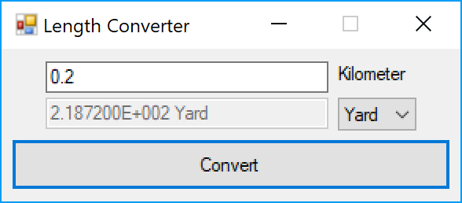

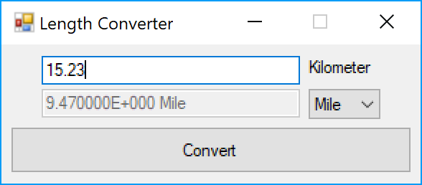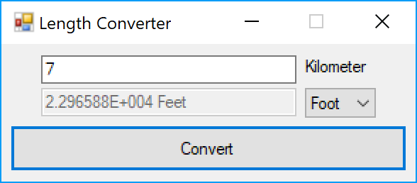

# Code

## Handler.cs

using System;

using System.Collections.Generic;

using System.Linq;

using System.Text;

using System.Threading.Tasks;

namespace CIS476Project2

{

abstract class Handler

{

protected Handler successor;

public abstract Handler HandleRequest(string type, string value);

public abstract string GetOutput();

public abstract string GetUnit();

public void SetSuccessor(Handler successor)

{

this.successor = successor;

}

}

}

## MileHandler.cs

using System;

using System.Collections.Generic;

using System.Linq;

using System.Text;

using System.Threading.Tasks;

namespace CIS476Project2

{

class MileHandler : Handler

{

private string output;

public override string GetOutput()

{

return output;

}

public override string GetUnit()

{

return "Mile";

}

public override Handler HandleRequest(string type, string value)

{

if (type.Equals("Mile"))

{

if (Double.TryParse(value, out double result))

{

output = (result / 1.609).ToString();

return this;

}

else

{

throw new FormatException("Invalid format. Input should be a integer or real number.");

}

}

else

{

if (successor != null)

{

return successor.HandleRequest(type, value);

}

return null;

}

}

}

}

## FootHandler.cs

using System;

using System.Collections.Generic;

using System.Linq;

using System.Text;

using System.Threading.Tasks;

namespace CIS476Project2

{

class FootHandler : Handler

{

private string output;

public override string GetOutput()

{

return output;

}

public override string GetUnit()

{

return "Feet";

}

public override Handler HandleRequest(string type, string value)

{

if (type.Equals("Foot"))

{

if (Double.TryParse(value, out double result))

{

output = (result * 3280.84).ToString();

return this;

}

else

{

throw new FormatException("Invalid format. Input should be a integer or real number.");

}

}

else

{

if (successor != null)

{

return successor.HandleRequest(type, value);

}

return null;

}

}

}

}

## YardHandler.cs

using System;

using System.Collections.Generic;

using System.Linq;

using System.Text;

using System.Threading.Tasks;

namespace CIS476Project2

{

class YardHandler : Handler

{

private string output;

public override string GetOutput()

{

return output;

}

public override string GetUnit()

{

return "Yard";

}

public override Handler HandleRequest(string type, string value)

{

if (type.Equals("Yard"))

{

if (Double.TryParse(value, out double result))

{

output = (result * 1093.613).ToString();

return this;

}

else

{

throw new FormatException("Invalid format. Input should be a integer or real number.");

}

}

else

{

if (successor != null)

{

return successor.HandleRequest(type, value);

}

return null;

}

}

}

}

## Decorator.cs

using System;

using System.Collections.Generic;

using System.Linq;

using System.Text;

using System.Threading.Tasks;

namespace CIS476Project2

{

abstract class Decorator : Handler

{

public override string GetOutput()

{

return "";

}

public override string GetUnit()

{

return "";

}

public override Handler HandleRequest(string type, string value)

{

return null;

}

}

}

## RoundDecorator.cs

using System;

using System.Collections.Generic;

using System.Linq;

using System.Text;

using System.Threading.Tasks;

namespace CIS476Project2

{

class RoundDecorator : Decorator

{

private Handler handler;

public RoundDecorator(Handler handler)

{

this.handler = handler;

}

public override string GetOutput()

{

return Math.Round(Double.Parse(handler.GetOutput()), 2).ToString();

}

public override string GetUnit()

{

return handler.GetUnit();

}

public override Handler HandleRequest(string type, string value)

{

return handler.HandleRequest(type, value);

}

}

}

## ExpDecorator.cs

using System;

using System.Collections.Generic;

using System.Linq;

using System.Text;

using System.Threading.Tasks;

namespace CIS476Project2

{

class ExpDecorator : Decorator

{

private Handler handler;

public ExpDecorator(Handler handler)

{

this.handler = handler;

}

public override string GetOutput()

{

return Double.Parse(handler.GetOutput()).ToString("E");

}

public override string GetUnit()

{

return handler.GetUnit();

}

public override Handler HandleRequest(string type, string value)

{

return handler.HandleRequest(type, value);

}

}

}

## ValutaDecorator.cs

using System;

using System.Collections.Generic;

using System.Linq;

using System.Text;

using System.Threading.Tasks;

namespace CIS476Project2

{

class ValutaDecorator : Decorator

{

private Handler handler;

public ValutaDecorator(Handler handler)

{

this.handler = handler;

}

public override string GetOutput()

{

return $"{handler.GetOutput()} {GetUnit()}";

}

public override string GetUnit()

{

return handler.GetUnit();

}

public override Handler HandleRequest(string type, string value)

{

return handler.HandleRequest(type, value);

}

}

}

## Form1.cs

using System;

using System.Collections.Generic;

using System.ComponentModel;

using System.Data;

using System.Drawing;

using System.Linq;

using System.Text;

using System.Threading.Tasks;

using System.Windows.Forms;

namespace CIS476Project2

{

public partial class MainForm : Form

{

private Handler mileHandler = new MileHandler();

private Handler yardHandler = new YardHandler();

private Handler footHandler = new FootHandler();

public MainForm()

{

mileHandler.SetSuccessor(yardHandler);

yardHandler.SetSuccessor(footHandler);

InitializeComponent();

}

private void ConvertInput()

{

try

{

var length = mileHandler.HandleRequest(UnitComboBox.Text, InputTextBox.Text);

length = new RoundDecorator(length);

length = new ExpDecorator(length);

length = new ValutaDecorator(length);

OutputTextBox.Text = length.GetOutput();

}

catch (FormatException ex)

{

OutputTextBox.Text = "Error";

MessageBox.Show(ex.Message, "Error");

}

catch (Exception ex)

{

OutputTextBox.Text = "Error";

MessageBox.Show(ex.Message, "Error");

}

}

private void MainForm_Load(object sender, EventArgs e)

{

UnitComboBox.SelectedItem = UnitComboBox.Items[0];

}

private void ConvertButton_Click(object sender, EventArgs e)

{

ConvertInput();

}

private void InputTextBox_KeyDown(object sender, KeyEventArgs e)

{

if (e.KeyCode.Equals(Keys.Enter))

{

ConvertInput();

}

}

}

}

## Form1.Designer.cs

namespace CIS476Project2

{

partial class MainForm

{

/// <summary>

/// Required designer variable.

/// </summary>

private System.ComponentModel.IContainer components = null;

/// <summary>

/// Clean up any resources being used.

/// </summary>

/// <param name="disposing">true if managed resources should be disposed; otherwise, false.</param>

protected override void Dispose(bool disposing)

{

if (disposing && (components != null))

{

components.Dispose();

}

base.Dispose(disposing);

}

#region Windows Form Designer generated code

/// <summary>

/// Required method for Designer support - do not modify

/// the contents of this method with the code editor.

/// </summary>

private void InitializeComponent()

{

this.InputLabel = new System.Windows.Forms.Label();

this.OutputTextBox = new System.Windows.Forms.TextBox();

this.UnitComboBox = new System.Windows.Forms.ComboBox();

this.ConvertButton = new System.Windows.Forms.Button();

this.InputTextBox = new System.Windows.Forms.TextBox();

this.SuspendLayout();

//

// InputLabel

//

this.InputLabel.AutoSize = true;

this.InputLabel.Location = new System.Drawing.Point(422, 18);

this.InputLabel.Name = "InputLabel";

this.InputLabel.Size = new System.Drawing.Size(102, 25);

this.InputLabel.TabIndex = 1;

this.InputLabel.Text = "Kilometer";

//

// OutputTextBox

//

this.OutputTextBox.Enabled = false;

this.OutputTextBox.Location = new System.Drawing.Point(55, 60);

this.OutputTextBox.Name = "OutputTextBox";

this.OutputTextBox.Size = new System.Drawing.Size(357, 31);

this.OutputTextBox.TabIndex = 2;

//

// UnitComboBox

//

this.UnitComboBox.DropDownStyle = System.Windows.Forms.ComboBoxStyle.DropDownList;

this.UnitComboBox.FormattingEnabled = true;

this.UnitComboBox.Items.AddRange(new object[] {

"Mile",

"Yard",

"Foot"});

this.UnitComboBox.Location = new System.Drawing.Point(427, 60);

this.UnitComboBox.Name = "UnitComboBox";

this.UnitComboBox.Size = new System.Drawing.Size(97, 33);

this.UnitComboBox.TabIndex = 3;

//

// ConvertButton

//

this.ConvertButton.Location = new System.Drawing.Point(13, 110);

this.ConvertButton.Name = "ConvertButton";

this.ConvertButton.Size = new System.Drawing.Size(559, 64);

this.ConvertButton.TabIndex = 4;

this.ConvertButton.Text = "Convert";

this.ConvertButton.UseVisualStyleBackColor = true;

this.ConvertButton.Click += new System.EventHandler(this.ConvertButton_Click);

//

// InputTextBox

//

this.InputTextBox.Location = new System.Drawing.Point(55, 15);

this.InputTextBox.Name = "InputTextBox";

this.InputTextBox.Size = new System.Drawing.Size(357, 31);

this.InputTextBox.TabIndex = 5;

this.InputTextBox.KeyDown += new System.Windows.Forms.KeyEventHandler(this.InputTextBox_KeyDown);

//

// MainForm

//

this.AutoScaleDimensions = new System.Drawing.SizeF(12F, 25F);

this.AutoScaleMode = System.Windows.Forms.AutoScaleMode.Font;

this.ClientSize = new System.Drawing.Size(584, 186);

this.Controls.Add(this.InputTextBox);

this.Controls.Add(this.ConvertButton);

this.Controls.Add(this.UnitComboBox);

this.Controls.Add(this.OutputTextBox);

this.Controls.Add(this.InputLabel);

this.FormBorderStyle = System.Windows.Forms.FormBorderStyle.FixedSingle;

this.MaximizeBox = false;

this.Name = "MainForm";

this.Text = "Length Converter";

this.Load += new System.EventHandler(this.MainForm_Load);

this.ResumeLayout(false);

this.PerformLayout();

}

#endregion

private System.Windows.Forms.Label InputLabel;

private System.Windows.Forms.TextBox OutputTextBox;

private System.Windows.Forms.ComboBox UnitComboBox;

private System.Windows.Forms.Button ConvertButton;

private System.Windows.Forms.TextBox InputTextBox;

}

}

## Program.cs

using System;

using System.Collections.Generic;

using System.Linq;

using System.Threading.Tasks;

using System.Windows.Forms;

namespace CIS476Project2

{

static class Program

{

/// <summary>

/// The main entry point for the application.

/// </summary>

[STAThread]

static void Main()

{

Application.EnableVisualStyles();

Application.SetCompatibleTextRenderingDefault(false);

Application.Run(new MainForm());

}

}

}